
ISLE OF AXHOLME SOUTH NEIGHBOURHOOD TEAM

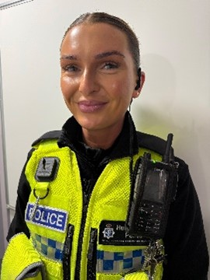
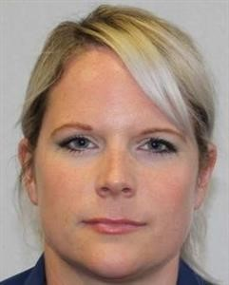
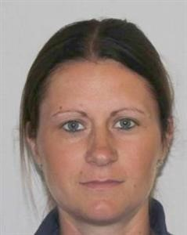
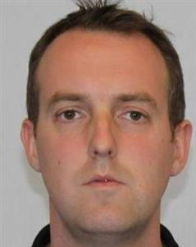


PCSO 7881
Katy McNALLY
PCSO 7611
Rebecca JENNINGS
PC 0425
Abbie ELLIS
Sergeant 1693
William HARRISON
EMERGENCY - 999
NON EMERGENCY – 101
ENQUIRIES – spoccommunitiesnorthlincolnshire@humberside.police.uk

