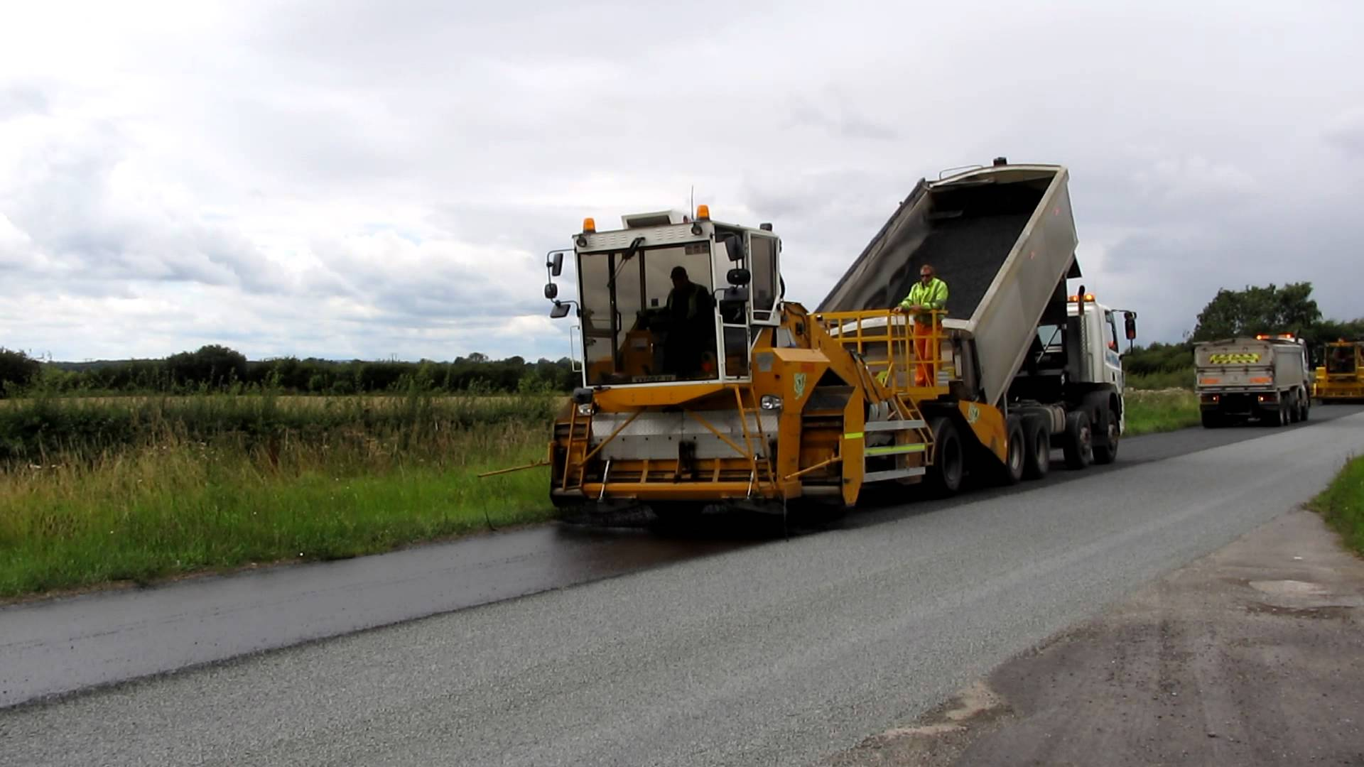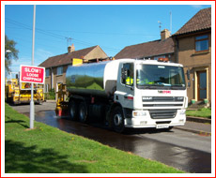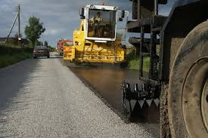

**Please be aware of proposed Carriageway Resurfacing work at;**

**Doncaster Road, Westwoodside**

**Between the Dates of;**

**15th August -2 days**

**Please Park Off-Road during the above dates or until work has been completed.**

**Work to be undertaken on behalf of North Lincolnshire Council by Kiely Bros Ltd.**

**For more information please contact:**

**Dave Warburton**

**Dave.warburton@northlincs.gov.uk**

**Senior Highways Project Officer**

**North Lincolnshire Council**

**What is Surface Dressing?**

The roads in your area are inspected regularly by North Lincolnshire Council Engineers to determine whether any maintenance work is required. It is important that road surfaces are sealed in order to prevent water ingress, oxidisation and onset of potholing. It is also important to have the correct surface texture. Your road has been identified as requiring such treatment.

Surface Dressing is a mixture of polymer modified bitumen emulsion and a layer of chippings. It will seal the surface, improve surface texture and prolong the life of the road. It is a speedy, efficient and economic method of preventative maintenance. The process is undertaken from late May to early August.

**The Surface Dressing Process**

* The surface dressing process is very weather dependent, it cannot be applied to wet or cold surfaces. Neither can it be laid during high air humidity levels or very high road surface temperatures.
* The road is swept and cleared of any built-up detritus and all ironwork is covered over.
* The Sprayer machine is then driven slowly along the road spreading the bitumen evenly across the width of the highway.
* This is followed closely by the chipping spreader and the application of the stone chippings.
* Depending on the type of surface dressing there may be several layers of bitumen/chippings applied.
* The material is then given an initial embedment with a pneumatic tyre roller.
* The material will remain wet for anything from 15 minutes to 40 minutes after it has been laid.
* Following completion, there will be a degree of loose chippings. These will be removed by a suction sweeper. The first sweep will take place 24 to 48 hours after the initial process.

**Notification of work**

Notices will be erected in the road stating exactly when the work will start. Please look out for these notices in order to ensure work is not delayed because of parked cars. We ask you to ensure that you do not leave your car parked on the road or footways when the work is due to start.

**During the Works**

* Traffic control measures will be put in place to create a safe working environment for the operatives.
* Generally, work will be carried out between 8.00 a.m. and 6.00 p.m.
* On street parking will not be possible during these times other than for very short durations.
* Vehicle access to your properties will be possible most of the time during the works but you may experience short delays immediately after the material has been laid. Pedestrian access to your property will be maintained throughout the works.
* Please drive slowly whilst travelling through the site. This is to protect our employees and your vehicle.
* Please do not hesitate to enlist the help of one of the operatives if you are in need of any assistance.
* Please do not attempt to drive or walk over the newly laid bitumen material until the chippings have been spread.

**After Completion**

The new surface can be driven on generally within 15 minutes after completion. An excess of loose aggregate will build up on the road for a period of time after completion. This is normal. Please drive slowly and observe the temporary signs that will have been left in place. The road will be swept again after a few days to remove the surplus aggregate. Further sweeping may be necessary for a while if there is continued stone loss. Depending on traffic flows it can be up to six months before the surface achieves its final visual and structural characteristics. For a short time, particularly if the weather is warm, there may be small areas of bitumen that are still soft. Please take great care. If you have to walk on the new surface please check your shoes before entering the house or getting into your car.

**Danger warning**

This work involves the use of heavy plant and machinery. Please do not allow your children to play near this equipment whether or not work is in progress.

**ADVANCE NOTICE OF HIGHWAY SURFACING WORK**